Standard Deviants: Accelerate login directions
- Go to sdaccelerate.com
- Click , then CREATE NEW ACCOUNT.
- Enter your login info; use your OPS email and password, then enter the invite code I provided.
- **If the next page displays:
…and there is nothing else to see, click “HOME” above.

- You should see a link for BIOLOGY (or whatever else I have unlocked for your class). Click it.
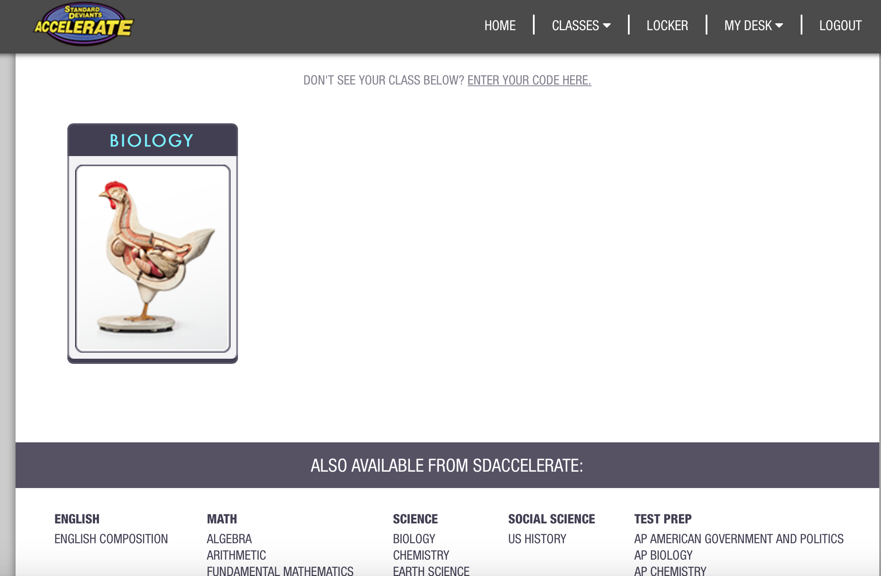

- From the menu that pops up below, choose the lesson that I have assigned for you.
- Begin by clicking on the VIDEO link at the top left. There is a transcript of everything the actors say during the video on the left to help you.
- After the video, you may want to click the VOCAB and DIAGRAM links as well to help your understanding of what you just saw.
- When you’re ready, click QUIZ to take a short, uh…, quiz.
- After the quiz, click WRITTEN ANSWER. Read the prompt completely and answer everything you can. You cannot get a 4 score on these assignments without doing a good job here.
The lessons are designed to progress from left to right, starting with VIDEO.

- As you turn in work, you can see your results by clicking LOCKER in the top right of any page. This will be your “journal” of everything you do on the website. NOW GO TRY SOME SCIENCE!

